# API Authentication – OAuth Token - UI Walkthrough

## **Goal**

Show the audience of learners where and how to set the GitHub UI to enable an OAuth Token.

### **Checklist**

* Click **OAuth Apps** in the left menu of **Settings > Developer Settings**.
* Under **Settings > Developer Settings > OAuth Apps**. Click **New OAuth App.**
* Points to highlight:
* **Obligatory fields:** Application name, Homepage URL (**Example:** oauth.companysite.com or http://localhost:8080) and Authorization callback URL (**Example:** oauth.companysite.com/callback or http://localhost:8080/oauth2callback).
  + After clicking **Register application**, point out that a **Client ID** is returned.
  + The client secret is not immediately returned. Generate it with the button **Generate a new client secret**. Important to highlight that the secret is displayed one time. So, the developer will need to note it.   
    *(Refesh the page to show this.)*
  + 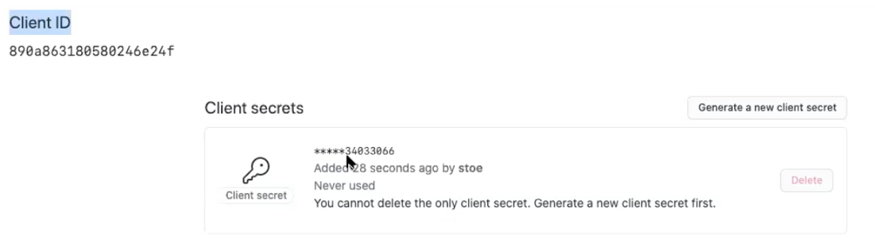
  + ***Important:***   
      
    Once you have the Client ID and Client Secret, you can authorize the user and select the scopes that their token builds. So, you are basically generating a sort of personal access on behalf of the OAuth application.

**Examples of this process:**

* Solutions such as Travis CI or Circle CI ask the user to authorize their services for GitHub.
* GitHub Desktop is another application that uses this process: making a request with a client ID and client secret to show you a site to grant authorization.
* Navigate to **Personal Settings > Applications > Authorized Oauth Apps** to show a list of authorized OAuth applications.

These are applications that have completed the authorization flow.

* Select one of the apps listed to show the following:
  + The button **Revoke access –** used to deny access to an application.
  + The list of permissions the application has been granted.